TRƯỜNG ĐẠI HỌC SÀI GÒN

KHOA CÔNG NGHỆ THÔNG TIN
NỘI DUNG: BÀI TẬP 01 DISCUSSION

Họ và tên: Trương Văn Thiện
MSSV: 3123410356

Hồ Chí Minh, ngày..., tháng..., năm...

I. INTRODUTION DISCUSSION
1. How do LLMs reason and what are the limits?
LLMs do not reason like humans; they predict the next token based on learned probability patterns. They can appear to reason thanks to chain-of-thought prompting, but this does not guarantee correct logic. Key limitations include hallucinations (making things up), math and logic errors, lack of genuine understanding, dependence on training data, bias, and difficulty retaining information over long contexts. Example: “If it rains, the road gets wet. The road is wet. Therefore, is it raining?” LLMs often answer incorrectly because they fall into the fallacy of affirming the consequent.
2. How do we make sure that LLMs generate factually correct output?
Use RAG so the LLM retrieves information from credible sources before answering. Require the model to cite its sources, use tools such as a calculator, web search, or databases, and cross-check claims. For high-stakes tasks, add human review, fine-tune the model, and require it to say “I’m not sure” when evidence is weak. For example, for medical questions, require citations from authoritative sources such as the WHO or the Ministry of Health, and do not trust answers that provide no sources
3. How do we fairly compensate the people who create the data that is used to train LLMs?
We need consent, transparent sourcing, proper attribution, and payment for licenses. We should build a data market, set up revenue-sharing funds, offer clear opt-in/opt-out mechanisms, and carry out data audits. For example, newspapers, Reddit, and artists should be paid when their work or data is used for training, and data labelers should also be fairly compensated for their work.
4. How do we use LLMs in learning, so human learning is not compromised?
We use them as a tutor to help us research and study new things, not as a machine that simply gives us answers. We should also ask “why?”, summarize in our own words, verify our understanding, and try solving problems ourselves before asking AI to check or correct our work. For example, students can use LLMs to outline the steps of an essay, then write the content themselves without copying text.
II. AGENTS DISCUSSION
1. If we have two cars and one provides more (expected) utility, which car is rational?
We should not say that cars themselves are rational. A rational choice means choosing the option with higher expected utility, given the same information and preferences. For example, if car A is safer, cheaper, and more cost-effective than car B, then choosing car A is rational. However, if you place a high value on environmental protection, car B might actually be the more rational choice.
2. Can a rational self-driving car be involved in an accident?
Yes, the vehicle can only make the best decision it can with limited information; it cannot predict everything. Accidents can still happen because someone else runs a red light, a pedestrian suddenly darts into the road, fog reduces visibility, a tire blows out, or a sensor fails. For example, flying is the rational choice for long-distance travel, yet accidents can still occur. Self-driving cars are similar: they reduce risk, but they do not eliminate it entirely.
3. How would a self-driving car explore and learn?
Training relies mainly on simulation, test tracks, fleet data, and shadow mode (running the new system in parallel without controlling the vehicle). There is a trade-off between exploration (trying new behaviors) and exploitation (using the best-known behavior). On public roads, exploration is tightly limited for safety reasons. For example, in simulation the vehicle can try many different following distances behind other cars, on real roads, it does not randomly experiment with passengers on board.
4. What does bounded rationality mean for a self-driving car?
It is rational within bounds: information, computation, time, sensors, and the world model are all limited. The vehicle does not seek absolute optimality; instead, it satisfices—choosing an option that is “safe enough and good enough” within a few tens of milliseconds. For example, it does not compute every possible move by every driver; it predicts plausible trajectories, selects the path with the lowest collision risk, and if uncertainty is high, it slows down or comes to a safe stop.
5. Design a structured representation for the state of a self-driving car.
a) What fluents should it contain?
- Location - kinematics: $x,y,v,θ,acceleration$
- Lane: $lane$, $lane_exists$, $gap_safe$
- Intrinsic car: $battery/fuel$, $mode$(cruise, yield, stop, emergency), $destination$, $sensor_ok$
- Environment: $traffic_light$, $speed_limit$, $weather$, $road_type$
- Object around: $lead_vehicle\left(d , istspeed\right)$, $pedestrian\left(pos\right)$, $obstacle\left(pos\right)$
- Safety -rules: $collision_risk$, $right_of_way$, $legal$
For example fluent: TrafficLight(red), LeadVehicle(d=15m, v=8m/s), InLane(2), Speed(12m/s), Mode(cruise).
b) What actions can cause transitions?
- accelerate(a): tăng tốc
- brake(b): giảm tốc
- steer(δ): đánh lái
- change_lane(L/R): chuyển làn
- stop(): dừng
- yield(): nhường đường
- emergency_brake(): phanh khẩn cấp
- turn(L/R): rẽ
- follow_vehicle(): bám xe trước
Each action has the precondition and effect.
For example:
- change_lane(L) has precondition: gap_safe ∧ lane_exists.
- emergency_brake() has effect: v' = 0, mode' = emergency.

c) Draw a small transition diagram.
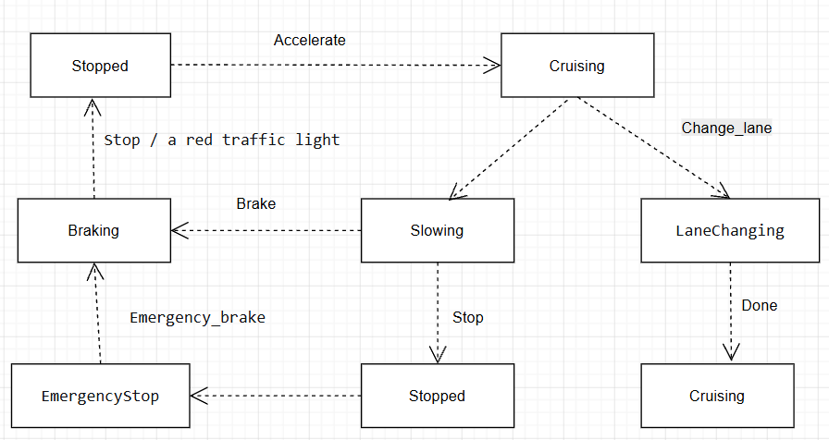
For example condition:
Stopped → Cruising: when the light turns green and the road is clear.
Cruising → Braking: when an obstacle appears or the light turns red.
Cruising → LaneChanging: when there are a safe gap and an available lane.
Cruising → EmergencyStop: when an immediate hazard is detected.
6. What Type of Intelligent Agent is a Self-Driving Car?
If we have to choose one type, it would be a utility-based agent, combined with model-based reasoning and learning. Such an agent does not merely achieve the goal of reaching the destination, it also balances safety, speed, comfort, fuel efficiency, and compliance with traffic rules.
6.1. Does it collect utility over time? How would the utility for each state be defined?
Yes. The vehicle accumulates expected utility over time, typically with discounting.
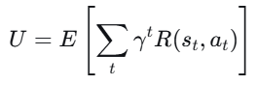
Uitility each state maybe the destination or reward:
U(s)=w1​⋅Safety+w2​⋅Progress+w3​⋅Comfort+w4​⋅Legal−w5​⋅CollisionRisk−w6​⋅Fuel
For example, the state travelling at 50km/h, 30m behind the lead vehicle, with a green traffic has high utility. The state 2m behind the lead vehicle at 60km/h has very low utility due to high risk.
6.2. Does it have a goal state?
Yes, but it does not have just a single goal. Goal states include reaching the destination, parking safely, avoiding collisions, and complying with traffic rules. If the car were only goal-based, it might choose a dangerous maneuver as long as it reached the destination. That is why a utility-based approach is needed to balance multiple objectives.
6.3. Does it store state information. How would they be defined (atomic/factored)?
Yes, and it is typically a factored representation, not an atomic one.
- Atomic: the entire state is treated as a single, indivisible block: S1, S2, S3, …
- Factored: the state is composed of multiple variables or fluents.
$$s=\left(x , y , v , l , a , n , e , traffic_lightlead_distbatteryweather\right)$$
Self-driving cars use factored (and often relational) representations to reason, predict, and make decisions. They also maintain a history and a belief state to handle hidden variables.
6.4. Does it use simple rules based on the current percepts?
Yes, to some extent, but not only that.
There is a simple reflex layer: “if an obstacle is closer than 5 m, apply emergency braking.” However, overall, the system uses a world model, predicts the behavior of other vehicles, performs planning, and optimizes utility. For example, “stop at a red light” is a simple rule, but “should I change lanes?” requires predicting distances and speeds of nearby vehicles, considering traffic rules, and evaluating utility.

